Title: **Numbers and Number Conversion** Test: 2

Course: Introduction to Automation Unit: Introduction to PLC CLO: 4

Name ____________________________ Grade ______ Date ______________

**Objectives**

1. Student shall describe different types of numbers.
2. Student shall demonstrate the ability to convert numbers from one numeric base system to another.

**Assessment**

Students shall demonstrate a comprehension of the objectives listed above by scoring a minimum of 75% on this Test. Grading shall be based on the answer key.

**Instructions**

Choose the best answer to each of the following multiple-choice questions.

1. A number that has only two states.
   1. Binary
   2. Integer
   3. Float
   4. Word
2. A number that represents a whole number.
   1. Binary
   2. Integer
   3. Float
   4. Word
3. A binary number can be converted to an integer and vise-versa.
   1. True
   2. False
4. Integers can be negative numbers.
   1. True
   2. False
5. A byte has ___ bits and can represent an integer up to _____?
   1. 8, 255
   2. 16, 65535
   3. 4, 128
   4. None of the above
6. Two _______ make a word?
   1. bits
   2. nibbles
   3. bytes
   4. None of the above
7. A _______ can be broken into four words?
   1. nibble
   2. bytes
   3. DWORD
   4. QWORD

Convert the following binaries to decimal

1. 1010 1100 __________
2. 0011 0100 __________
3. 1100 1001 __________
4. 0110 1011 __________
5. 1111 0101 __________

Convert the following decimals to binaries.

1. 112 __________
2. 43 __________
3. 59 __________
4. 255 __________
5. 191 __________
6. 100 __________

Circle the following addresses in the appropriate table.

1. 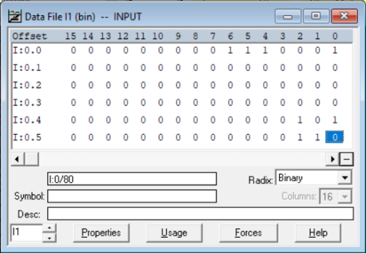O:0.0/3
2. I:0.1/5
3. 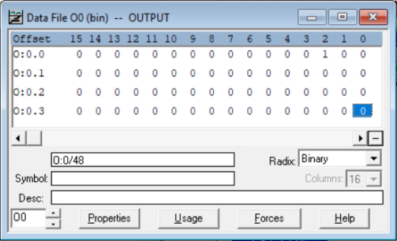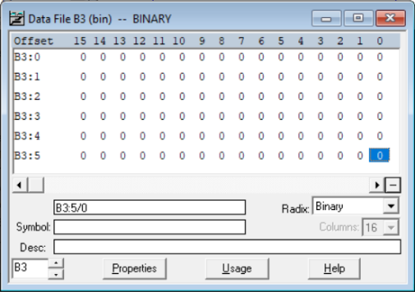B3:2/5